**The True Heir to the MVP Throne**

--- Intro

“Not again, not this year too!” famous last words of Celtics fans as they witnessed another heart-breaking end to an inspiring playoffs run. History repeated is self and it was once again Boston's kryptonite that burned them alive in their own home - LeBron of the House James, The Chosen one, protector of the league, king of the Eastern conference, breaker of the Raptors, mother of the worst teammates to ever reach the finals and the true Heir to the Finals MVP throne. Lebron’s playoff 2017 playoff performances have be Khalesi like – unstoppable and addictive to watch. The lack of quality supportive players has forced the King to unleash into a level we have never seen before and for that only he deserved to sit on the Finals MVP Throne.

~~Basic or advanced stats point to LeBron playing at a level we have never seen before - strengthening his case in THE greatest of all time debate. To avoid robbing Harden again let's give him the regular season MVP. But win or lose these Finals, LeBron James deserves to at least win the Finals MVP.~~

If you’ve paid ~~the slightest of~~ any attention to this year's playoffs, you would know LeBron’s numbers have been unbelievable - he currently leads the Playoffs in points, assists, minutes played and add to that he already has seven 40 point games. When all odds are stacked against him as he . As most NBA analysts like to talk about stand alone statistics, I want to approach analysis his production on a different angle - James’ impact on each series relative to everyone else — combined.

I’ve created a list of the percentage of a player’s total points, assists and rebounds relative anyone else in a series and James’ fingerprints are all over it. From the first round against Indiana to the Finals he has consistently crowned the rest of the players by impacting in more than 16 percent of all the points, assists and rebounds. Every series he’s played so far, he has dominated the game and outdone the rest of the league as did Khalesi

**Caption – top 25 players percentage share of all the points, assists and rebounds of a series

The Finals MVP is traditionally awarded to the best player from the winning team during the finals. It doesn’t take into account performance in rounds before that. However the NBA has to make an exception this year. His performance in each series is far superior to any other star in this league. The closest player to James from the Finals is Kevin Durant and he’s still 3% behind.

If we compare historically, the last player to closest to James who didn’t win the Finals MVP was Kareem Abdul-Jabar, who had 15.5 percent share in the 1974 finals. Jerry West had 13.5 percent share in 1969 in a losing effort and was still awarded Finals MVP. Jeff Van Gundy said it best, “LeBron has to play the best basketball of his career for his team to even have a chance, compared to players on the Warriors team who can have off nights and rely on other All Stars to contribute.”

If outperforming his competitors by large margins, piggy backing sub-par team mates and setting NBA records isn’t enough to award LeBron Finals MVP, consider this.

GRAPHIC THREE

Share

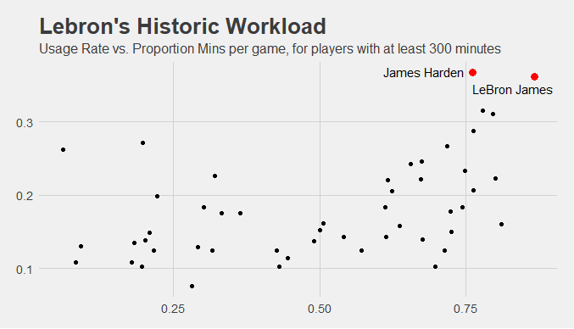

Plots the difference of percent share between the top two players of each series against percent/portion of minutes player per game

Once again, the King himself has outshined his peers by a large margin. C

There may be a debate about MJ vs Lebron for GOAT, but there certainly is no questioning about the most conditioned player to ever play the game. Coming into the playoffs Lebron had already played x% out of total minutes in the regular season, that’s X many minutes/games more than the second most minutes _____________ . In addition to this, James has had to carry an unimaginable workload during the playoffs. His usage rate is only 0.5% shy of ‘dribble dribble dribble and shoot’ James Harden. Coach Lue very rarely gives his star player a rest – playing him the full 48 minutes during the Game 7 against Boston. Being the most used and worked player during the regular season and playoffs has not stopped James from exemplifying greatness.